**EE 462-EE464**

**Project**

**Design of a SM-PMSM Variable Frequency Drive with Matlab/Simulink**



**Student 1 & ID: Anıl Yalçınkaya & 2376085**

**Student 2 & ID: Hüsnü Oğuz Yorgancılar & 2305787**

# **Part A: Pre-design Stage**

1)

$$P_{nom}=120kW, { T}_{nom}=350Nm, r=0.3m => w_{base}= \frac{P_{nom}}{T_{nom}}=342.86\frac{rad}{s}$$

$$v_{base,vehicle}=\frac{w_{base}*r}{8.5}=12.1(102.86)\frac{m}{s}=43.56(370.29)\frac{km}{h}$$

2)

$$n_{max}=14000rpm, pp=4 => w_{e,max}= \frac{n_{max}*2π*pp}{60}=5864\frac{rad}{s}$$

$$w_{e,max}=2πf_{e,max} => f_{e,max}=933.3Hz$$

For switching frequency, we have chosen 10 $f_{e,max}$* like given in EE462 course, so

$$f_{sw}=9333.3Hz$$

3)

Source is 50Hz, 300Vl-l = 173.21Vph,rms , Vph,peak=244.95V. We have three phase voltage rectifier, so rms of the output voltage is 1.35Vl-l = 405.14V without any filter. To find resistive load equivalent to motor at rated current of 530A, P/I2=R=120000/530^2=0.4272Ω. From simulation, we determined to use LC filter with 100uF capacitor and 3mH inductor giving an output ripple of 3.1V corresponding to 0.79% ripple which is convenient. Note that voltage rms is not exactly the same as 405.14V due to losses and voltage drop on diodes. However, when inductance is used, the input waveforms are not as desired unexpectedly when the motor is connected instead of resistor. So, we did not used inductor when simulating.

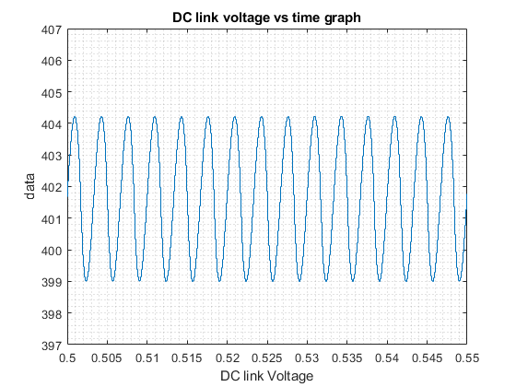

Figure 1: DC link voltage vs time graph

# **Part B: Sinusoidal PWM**

Equivalent inertia seen at the electric machine shaft is found as follows:

$$J_{rot}=0.5kgm^{2}, J_{wheel}=1kgm^{2}, \frac{w_{em}}{w_{wheel}}=8.5, F_{load}=150+0.35v^{2}$$

$$J_{vehicle}= 4*1+1500*{0.3}^{2}=139kgm^{2} J_{eq}= J_{vehicle}{\left(\frac{w_{em}}{w_{wheel}}\right)}^{2}+J_{rot}=2.42kgm^{2}$$

$$T_{load}=F_{load}*r=45+0.00945v^{2}$$

Load seen at the electric machine shaft is found as follows:

$$T_{wheel}=F_{load}*r=45+0.00945{w_{wheel}}^{2}, T_{em}= T_{wheel}\left(\frac{w_{wheel}}{w_{em}}\right)= 5.29+1.53*{10}^{-5}{w_{em}}^{2}$$

1)

**Drive model 1:**

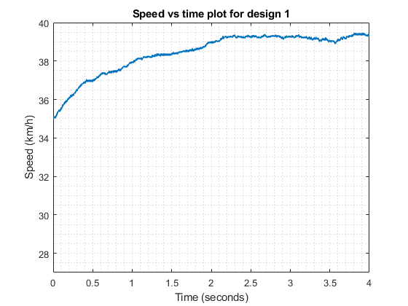

Figure 2: Speed for drive model 1 from 35-40km/h

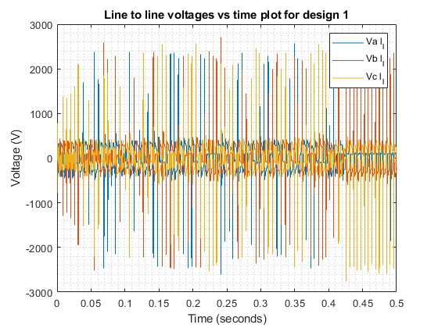

Figure 3: Line-line voltages for drive model 1 from 35-40km/h

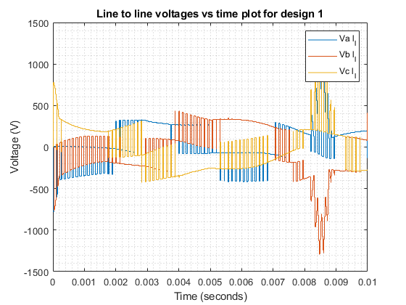

Figure 4: Line-line voltages at the start for drive model 1 from 35-40km/h

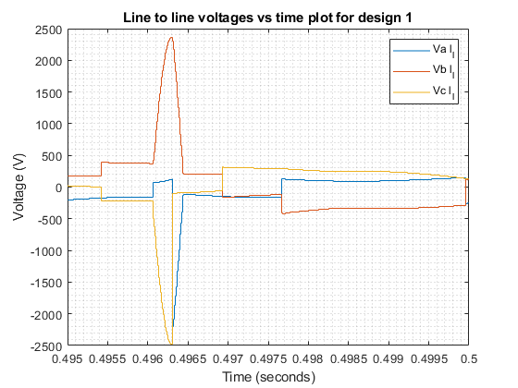

Figure 5: Line-line voltages in the end for drive model 1 from 35-40km/h

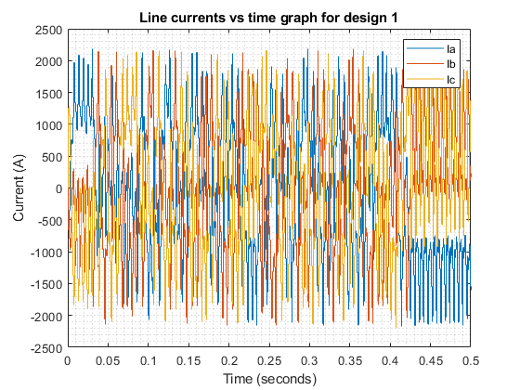

Figure 6: Line currents for drive model 1 from 35-40km/h

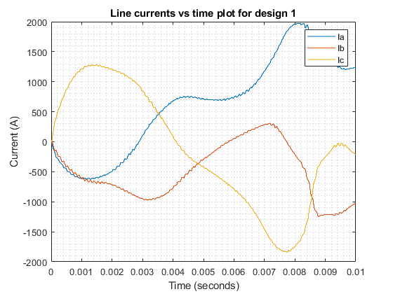

Figure 7: Line currents at the start for drive model 1 from 35-40km/h

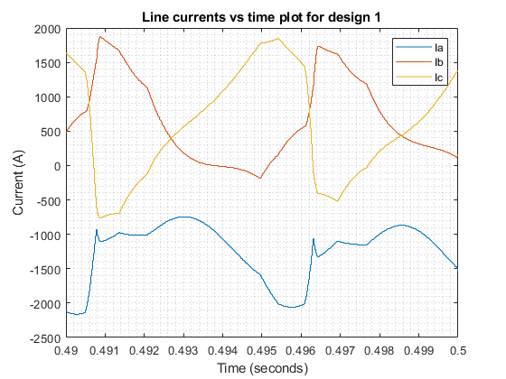

Figure 8: Line currents in the end for drive model 1 from 35-40km/h

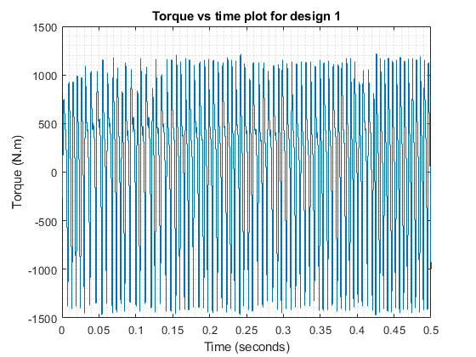

Figure 9: Torque for drive model 1 from 35-40km/h

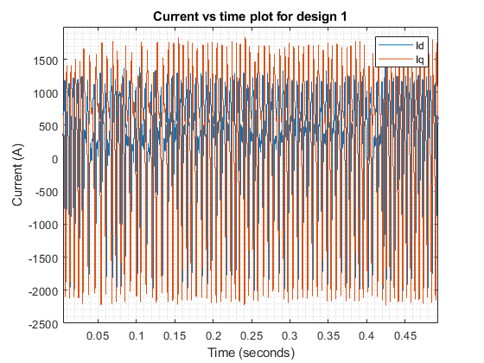

Figure 10: d-q currents for drive model 1 from 35-40km/h

**Transition time:** None, because it does not reach 40km/h

**Drive model 2:**

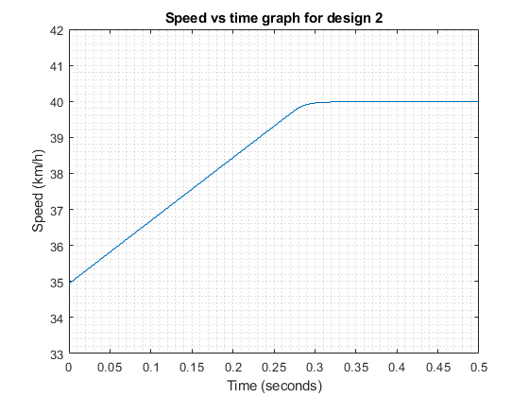

Figure 11: Speed for drive model 2 from 35-40km/h

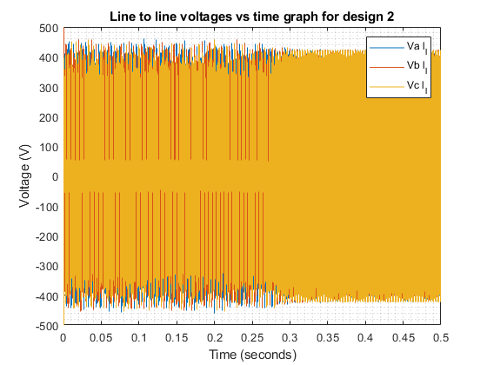

Figure 12: Line-line voltages for drive model 2 from 35-40km/h

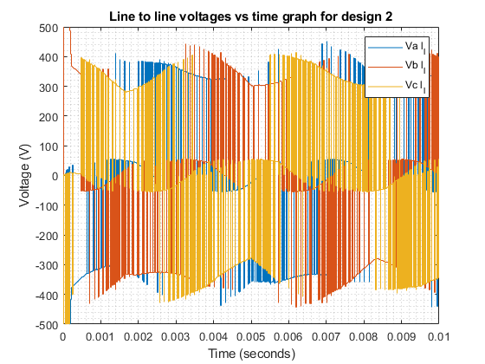

Figure 13: Line-line voltages at the start for drive model 2 from 35-40km/h

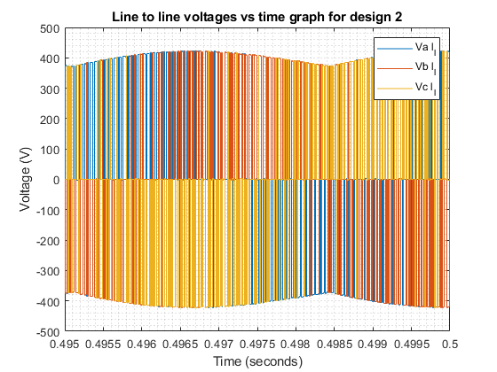

Figure 14: Line-line voltages in the end for drive model 2 from 35-40km/h

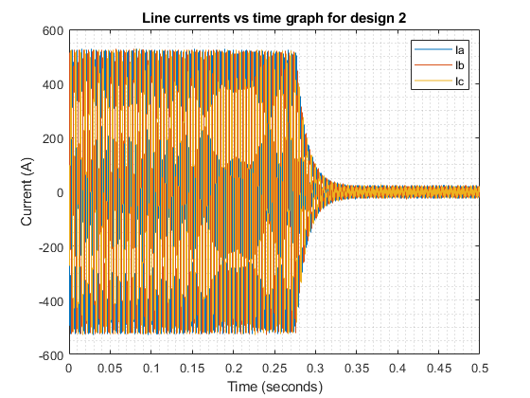

Figure 15: Line currents for drive model 2 from 35-40km/h

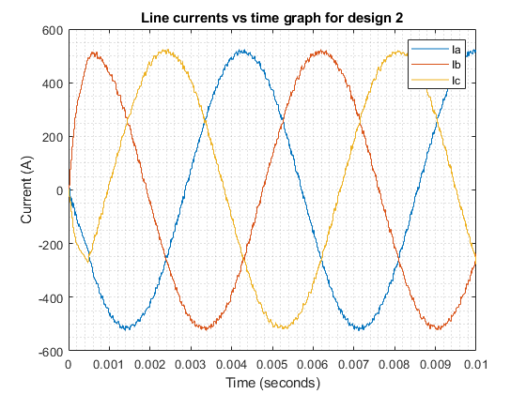

Figure 16: Line currents at the start for drive model 2 from 35-40km/h

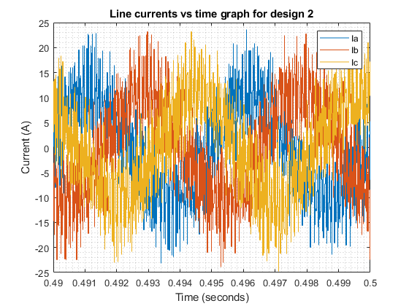

Figure 17: Line currents in the end for drive model 2 from 35-40km/h

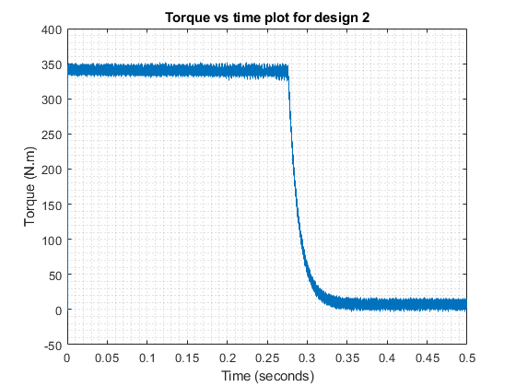

Figure 18: Torque for drive model 2 from 35-40km/h

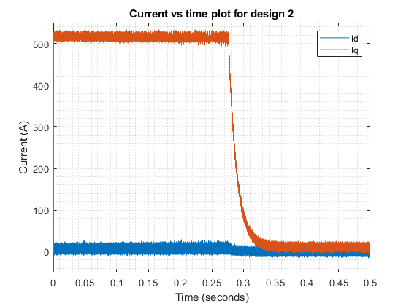

Figure 19: d-q currents for drive model 2 from 35-40km/h

**Transition time:** 0.3s

**Drive model 3:**

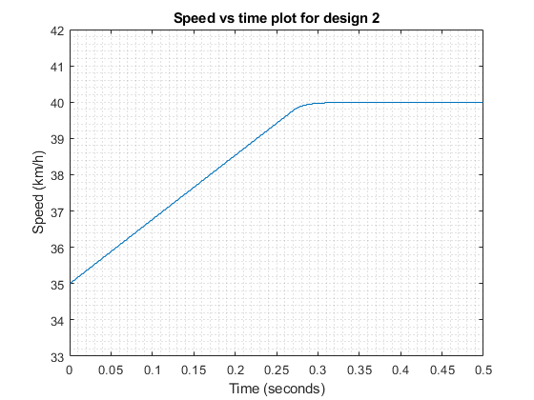

Figure 20: Speed for drive model 3 from 35-40km/h

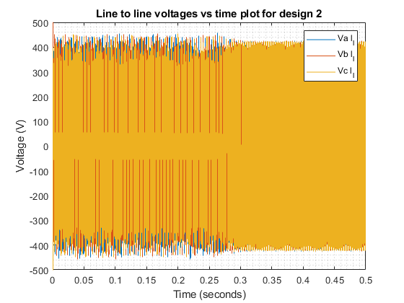

Figure 21: Line-line voltages for drive model 3 from 35-40km/h

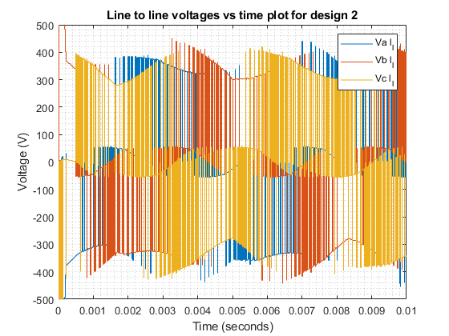

Figure 22: Line-line voltages at the start for drive model 3 from 35-40km/h

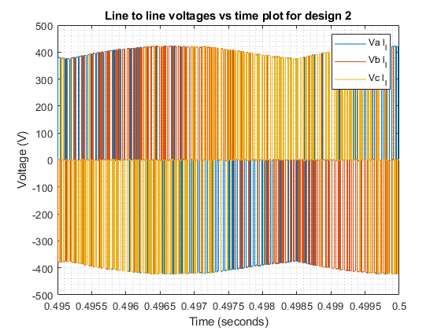

Figure 23: Line-line voltages in the end for drive model 3 from 35-40km/h

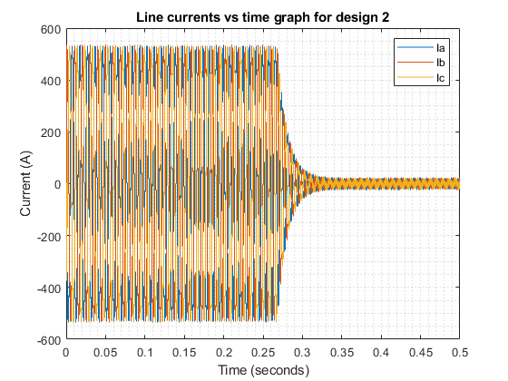

Figure 24: Line currents for drive model 3 from 35-40km/h

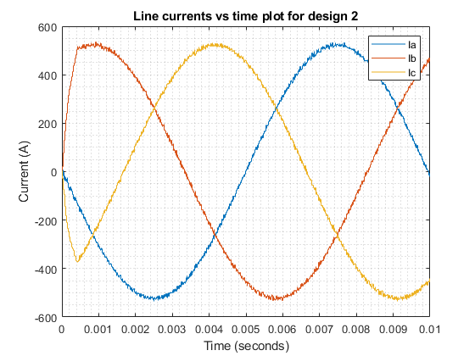

Figure 25: Line currents at the start for drive model 3 from 35-40km/h

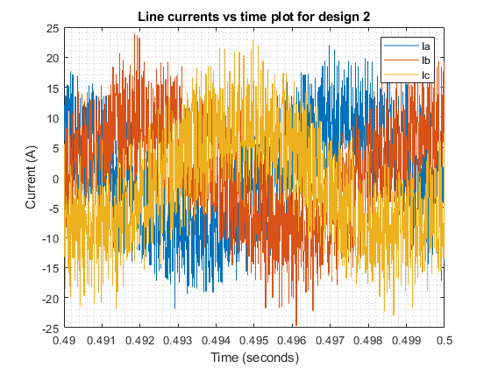

Figure 26: Line currents in the end for drive model 3 from 35-40km/h

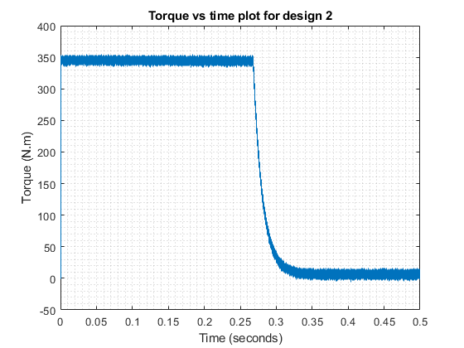

Figure 27: Torque for drive model 3 from 35-40km/h

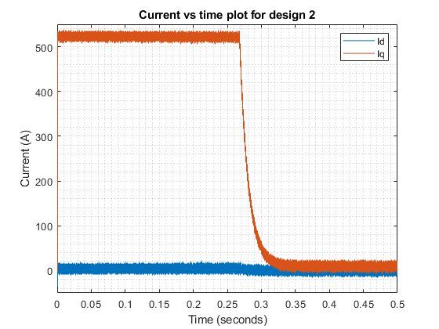

Figure 28: d-q currents for drive model 3 from 35-40km/h

**Transition time:** 0.3s

2)

With design 1 we suspect there is something wrong we can observe that almost all the values go beyond the rated values. Waveforms are all over the place with full of massive transients. But our closed loop is somewhat working because our speed did increase but even after 4 seconds it did not reach 40 km/h and stuck around 39.5 km/h. While, designs 2 and 3 reached 40 km/h at 0.3 seconds. As we can see main problem with this design is that our torque waveform is oscillating between negative and positive values. We did add limiter to the system for our Iq values to prevent values going to higher than rated values, but it did not work.

We also taken Id as 0 this may cause problem because even though we take it as 0 it may not be 0 but we could not think of a way to incorporate id to the system without current feedback. Also, when we connected Id from motor directly to dq-abc transformation results were even worse. Trying different P and I values did not helped either.

Compered to design 1 design 2 and design 3 worked well and their waveforms are almost same. From this we can conclude that with current control we can achieve stable system with relative ease. Speed waveform of these designs are very smooth.

Line to line voltages at the before we reach 40km/h is curved squarish waveform but after we reach the 40km/h our waveform is much closer to sinusoidal PWM we know and love. Reason for this could be that when car is accelerating motor draws much more current as we can see from line current waveform. With high amount of current passing through motor inductance our phase angle is increased, and waveform comes differently.

When car is accelerating current passing through it is rated current as expected and this current is reduced dramatically when 40km/h is reached. This is because load torque is very low only small amount of power is enough to keep car’s speed constant.

As we can see line currents before we reached 40km/h is sinusoidal with small transients and disturbances waveform is like what we expected. But after we reached 40km/h waveform looks like modern art. It is full of transients and in triangular shape. It still has sinusoidal component thus it can keep car at the constant speed. Reason for it being this disturbed is that with low current same amount of disturbance effect waveform much more.

From torque waveform we can see that it is below rated torque and oscillations and transients are relatively small. Oscillation around 20 N.m. Iq has same waveform as Tem just with bigger magnitude because they are directly correlated. Iq also does not pass rated current of 530 A. Id shares with them same oscillations and transients, but its average magnitude is around 0.

There is no notable difference between design 2 and 3 even looking closer they look almost exactly same.

3)

**Drive model 1:**

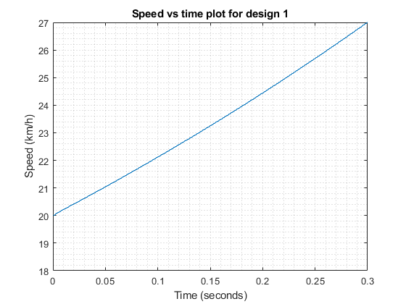

Figure 29: Speed for drive model 1 from 20-25km/h

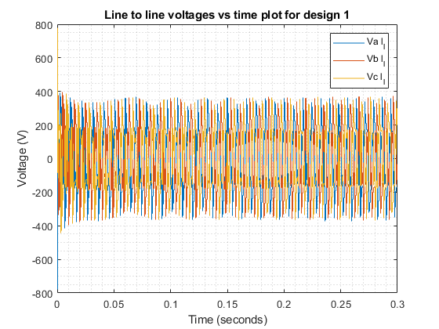

Figure 30: Line-line voltages for drive model 1 from 20-25km/h

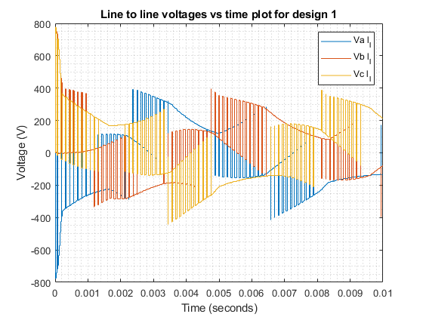

Figure 31: Line-line voltages at the start for drive model 1 from 20-25km/h

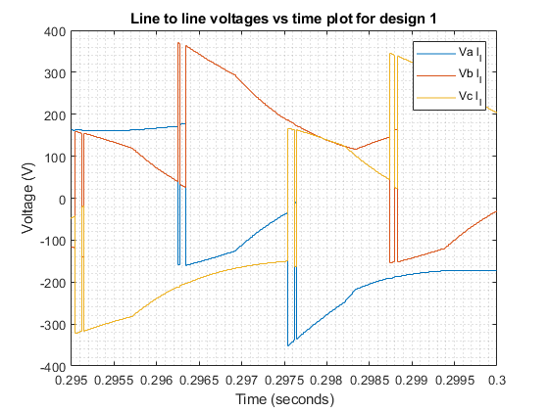

Figure 32: Line-line voltages in the end for drive model 1 from 20-25km/h

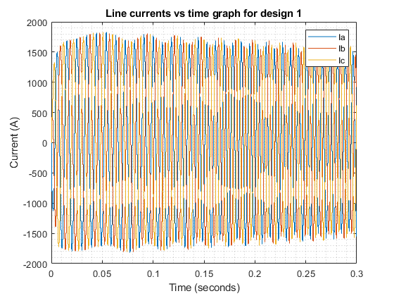

Figure 33: Line currents for drive model 1 from 20-25km/h

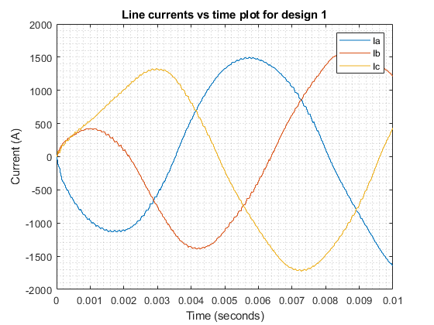

Figure 34: Line currents at the start for drive model 1 from 20-25km/h

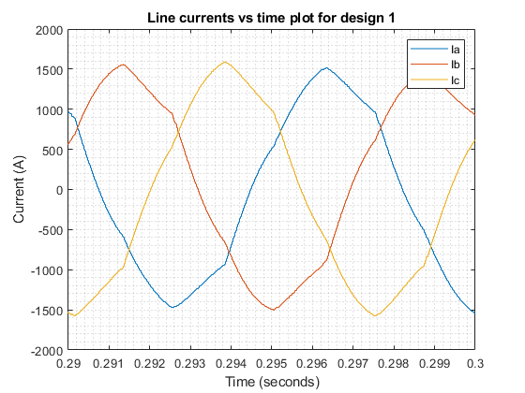

Figure 35: Line currents in the end for drive model 1 from 20-25km/h

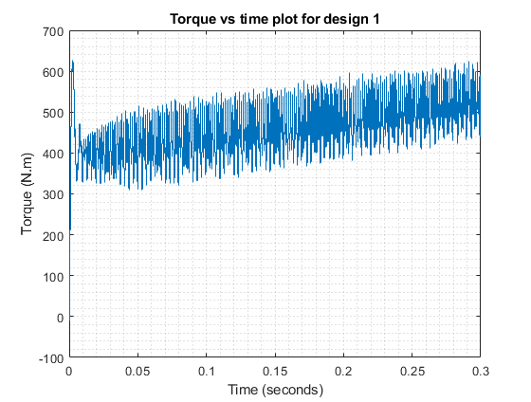

Figure 36: Torque for drive model 1 from 20-25km/h

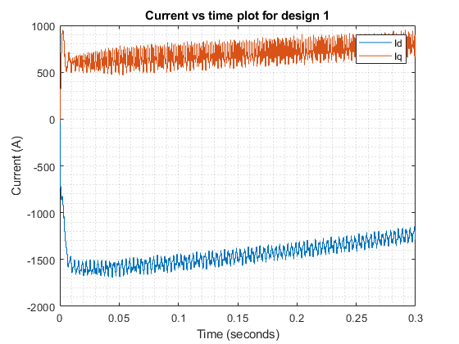

Figure 37: d-q currents for drive model 1 from 20-25km/h

**Transition time:** None, because it passes 25km/h and do not converge to it

**Drive model 2:**

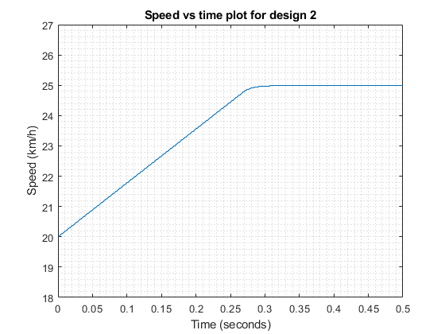

Figure 38: Speed for drive model 2 from 20-25km/h

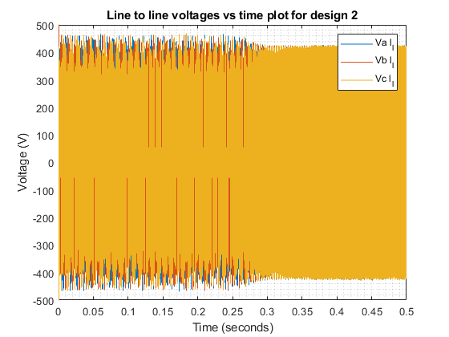

Figure 39: Line-line voltages for drive model 2 from 20-25km/h

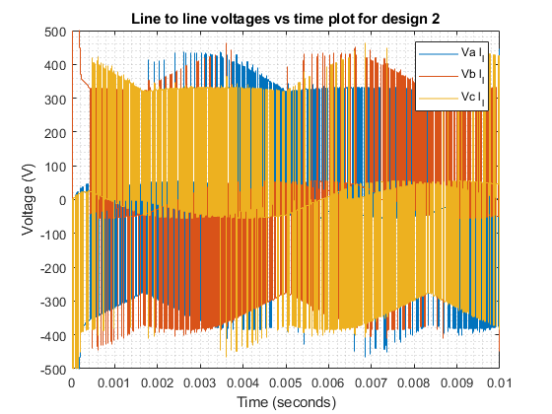

Figure 40: Line-line voltages at the start for drive model 2 from 20-25km/h

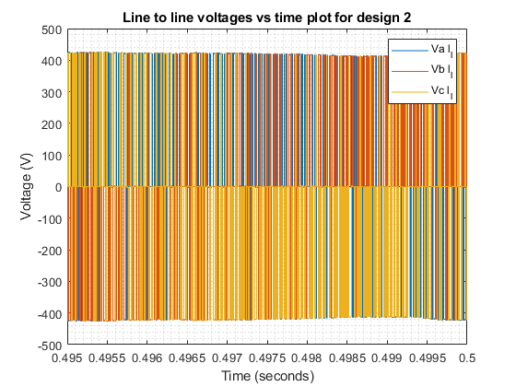

Figure 41: Line-line voltages in the end for drive model 2 from 20-25km/h



Figure 42: Line currents for drive model 2 from 20-25km/h



Figure 43: Line currents at the start for drive model 2 from 20-25km/h



Figure 44: Line currents in the end for drive model 2 from 20-25km/h



Figure 45: Torque for drive model 2 from 20-25km/h



Figure 46: d-q currents for drive model 2 from 20-25km/h

**Transition time:** 0.3s

**Drive model 3:**

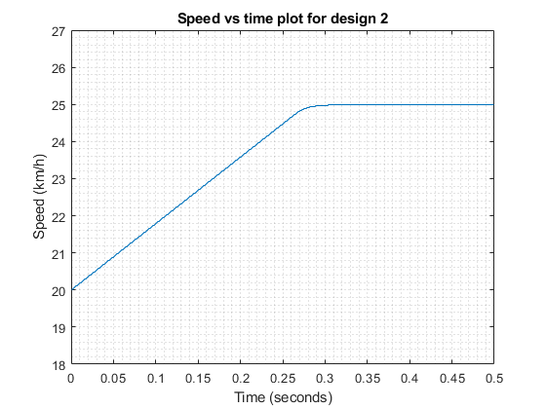

Figure 47: Speed for drive model 3 from 20-25km/h

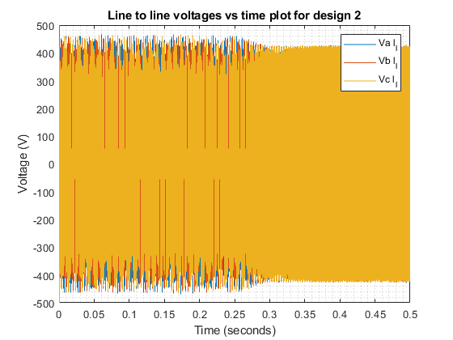

Figure 48: Line-line voltages for drive model 3 from 20-25km/h

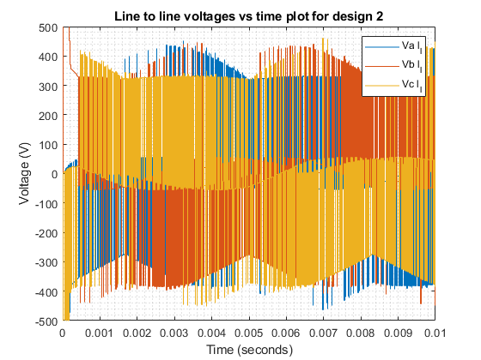

Figure 49: Line-line voltages at the start for drive model 3 from 20-25km/h

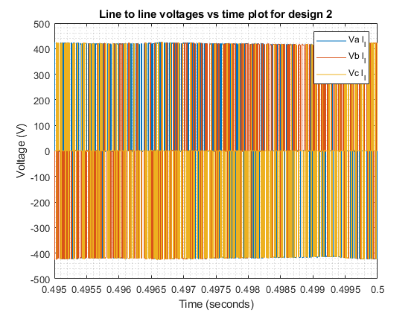

Figure 50: Line-line voltages in the end for drive model 3 from 20-25km/h

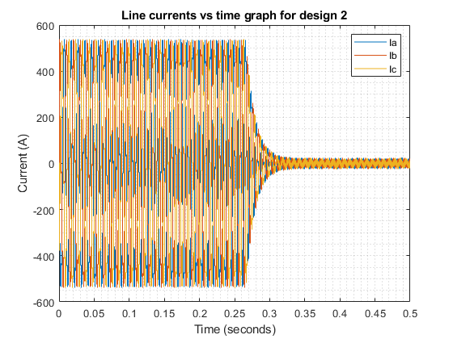

Figure 51: Line currents for drive model 3 from 20-25km/h

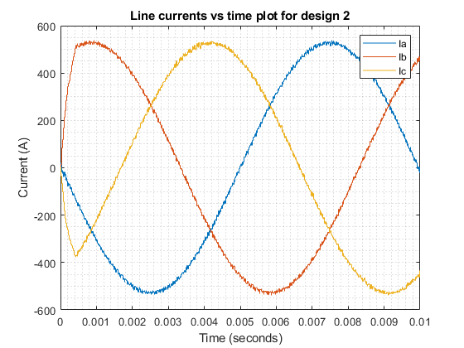

Figure 52: Line currents at the start for drive model 3 from 20-25km/h

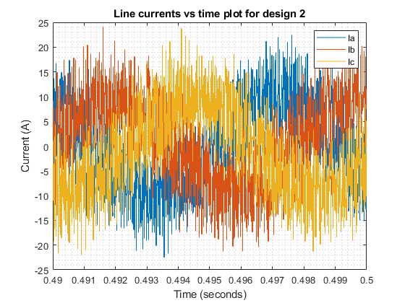

Figure 53: Line currents in the end for drive model 3 from 20-25km/h

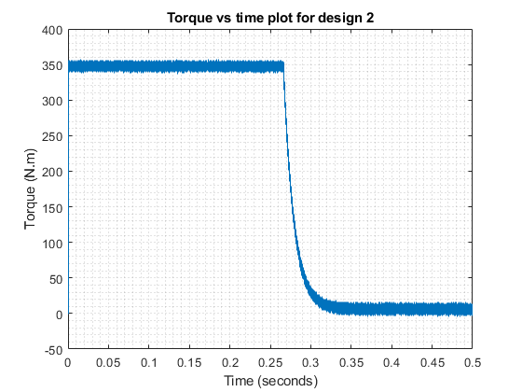

Figure 54: Torque for drive model 3 from 20-25km/h

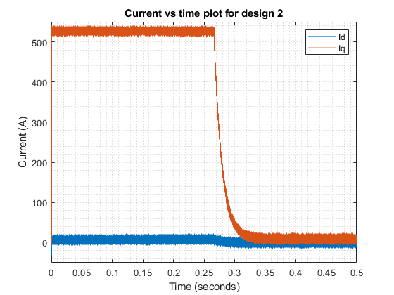

Figure 55: Torque for drive model 3 from 20-25km/h

**Transition time:** 0.3s

4)

When we reduced starting speed from 35 to 20 km/h we observed biggest change in waveforms of design 1. It is still full transients. However, speed actually increase consistently. Car reaches 25 km/h at 0.22 seconds compared to 0.3 seconds of design 2 and 3. But torque reaches values higher that rated value in order to do so. There is still probably a limiter needed to limit these values, but it is improved compared to part 1. From this we can conclude that design 1 can reach stable state with some tinkering. This time although line currents is above rated value and stays, so line to line voltage values is within limits. Iq value starts at 530A and slowly increases above rated value. There are still transients and oscillations that are larger than design 1 and 2 but it is lot better compered to all over the place waveform of one in the part 1. Real problem is Id value which goes to minus -1500A, three times the rated value. That is probably caused by fact that we do not control Id.

When we look at waveforms of design 2 and 3 there is not much difference. Biggest difference we observed is change of frequency of line currents and line to line voltages. This is expected because rotation speed is directly correlated with electrical frequency in synchronous motors. Time to increase speed by 5km/h is same as part-1, 0.3 seconds. We think because velocity dependent part of load torque is very small and does not affect speed much. Load torque generally does not affect speed much because it is small. And because we are in base speed region, we can provide same current and voltages at both of these speeds.

5)

Half of the rated torque means load torque is 175Nm.

At v=60km/h means wem=472.2rad/s and at this speed, maximum torque is 120000/472.2=254.12Nm. we=1888.8 rad/s. Ld=Lq=165µH, Vph,lim=200.8V as found in part-B.

At T=254.12Nm,

$$T_{em}=\left(\frac{3}{2}\right)ppλ_{pm}i_{q}, i_{q}=\frac{254.12}{\frac{3}{2}*4*0.11}=385A$$

Voltage limit:

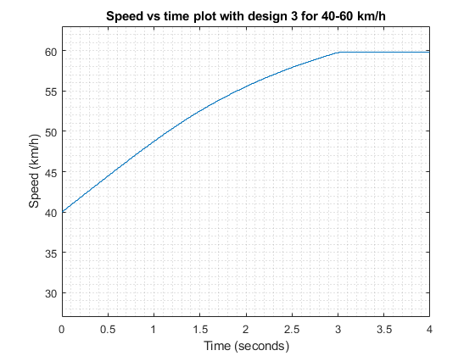

Figure 56: Speed for drive model 3 from 40-60km/h

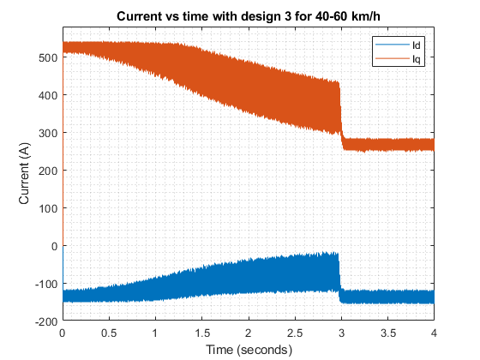

Figure 57: d-q currents for drive model 3 from 40-60km/h

# **Part C: Component Selection**

1)

As simulated in part-B, the maximum voltage and current values are found around 450V and 530A, so a safe choice for these ratings could be 600V 600A rating. To satisfy this rating, PM600CLA060 three phase 600V 600A IGBT Power Module is chosen.

2)

$$P_{sw}=6*\frac{1}{2}V_{off}I_{on}\left(t_{on}+t_{off}\right)f_{sw}=6*\frac{1}{2}405*530*5.9*{10}^{-6}*9333=35.3kW$$

$$P_{con}=6*V_{f}I_{av}=6*3.7*120=2.6kW$$

$$P_{loss}=P_{sw}+P_{con}= 37.9kW=>31\% loss$$

which is a very high loss. Since the on off times are high for this model, it highly increases the switching loss. Also, forward voltage is quite high, increasing conduction loss. All these losses increase the temperature of the device and makes the thermal management difficult.

3)

A three phase SPWM module for power inverters is searched and it is seen that FPGAs can be used for this task. So, one model that is already used in a research[1] is Xilinx FPGA SPARTAN 3E card.

Appendix

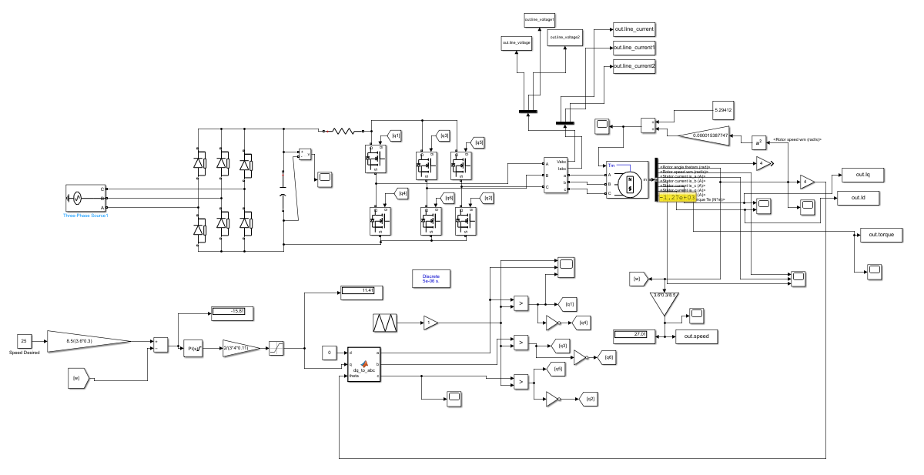

Figure 58: Drive model 1 (P=0.02 I=2)

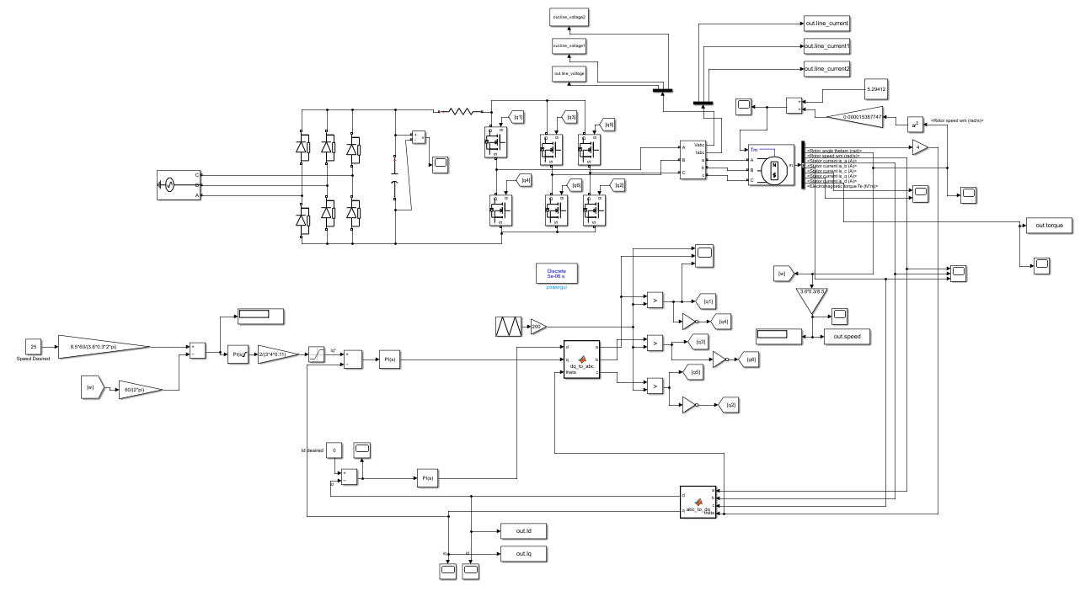

Figure 59: Drive model 2 (P=20, I=-0.1 for all PI controllers)

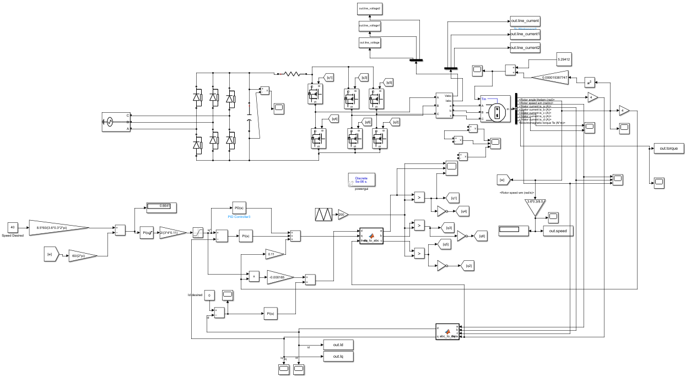

Figure 60: Drive model 3 (P=20, I=-0.1 for all PI controllers)

References

[1] https://www.researchgate.net/publication/333973827_WIDE_RANGE_MODULATION_INDEX_VARIATIONFPGA_BASED_SPWM_THREE-PHASE_INVERTER